Self Help Guide
Resetting a forgotten or expired password
Once password recovery options have been set on your account, you will be able to reset your password at any time, without having to contact the IT Service Desk.
This option allows you to reset your password if it has expired or if you have forgotten it. This option also helps you to unlock your account. If you know your password and need to change it, please follow the instructions to change your password.
- Go to https://mypassword.bucks.ac.uk and choose the option to reset your password.

Enter your Bucks email*, using one of the below formats:

For Students (including Partner College students): <StudentID>@bucks.ac.uk (e.g 23456789@bucks.ac.uk)

For Bucks Staff: <FirstName.LastName>@bucks.ac.uk (e.g. Joe.Bloggs@bucks.ac.uk)

For Partner College Staff: <FirstName.LastName>@partner.bucks.ac.uk (e.g. Joe.Bloggs@partner.bucks.ac.uk)

*Partner college staff don’t need a Bucks email to reset their password, the above UPN will be set up to allow access.

Please ensure you are logged out of any Microsoft linked account before commencing setup (Outlook, Hotmail, Live, college or other organisational account)

Once this is complete enter the captcha code and click Next.

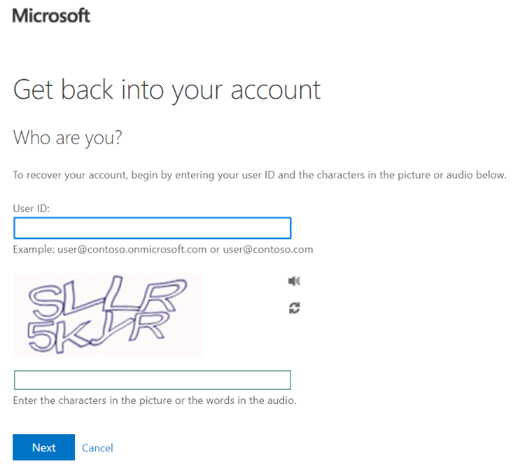

- Choose one of the below options and then click Next.

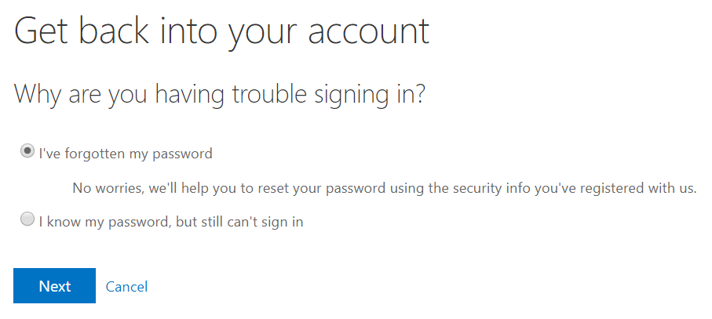

- You are now presented with the password recovery options you have previously set up. Choose one of the options and a verification code will be sent to that preferred contact method.

If you need to change or add options, once you have a valid password navigate to https://aka.ms/ssprsetup to make the necessary updates.

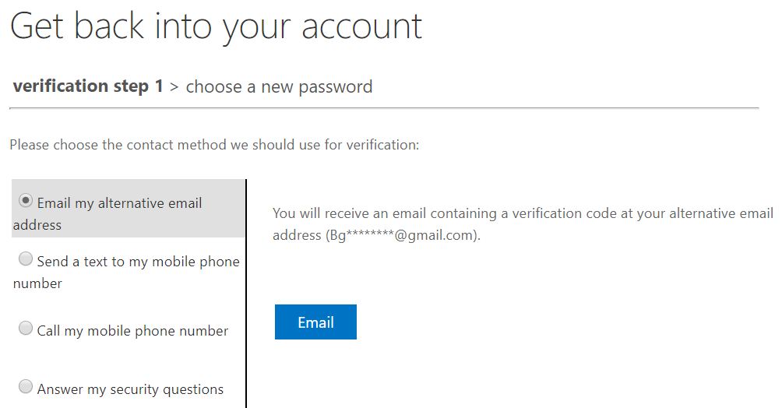

- Once the verification code has been received, enter it and click Next.
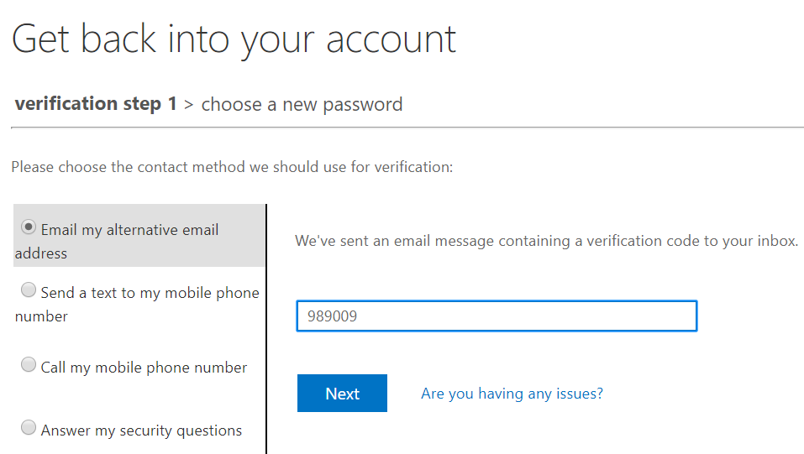

- Set a new password on your account. Please view the Password Management page for password tips/do’s and don’ts.

Click Finish once your password has been set, you will receive confirmation that the reset was successful.
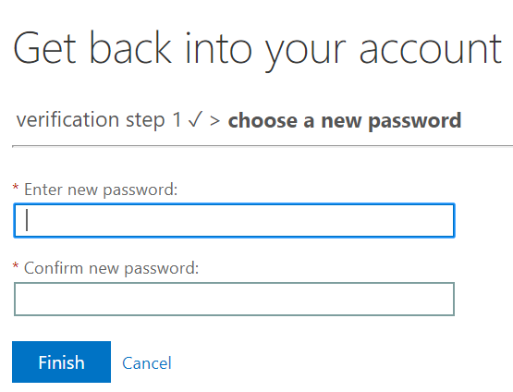

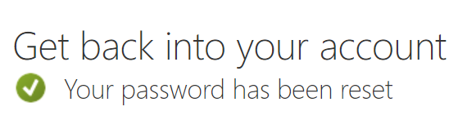

Your password has now been reset and is valid for 12 months, however if at any time you believe your password has been compromised or made available to others, you must immediately change it and notify the IT Service Desk.
If you experience any issues resetting your password, please contact the IT Service Desk by emailing IT@bucks.ac.uk, calling 01494-605000 (Option 1) or visiting us on Level 2 in the Gateway Building.

